40hs

Si actualizamos las quantities, se actualiza el cart.
Add a new button called add to cart, that when pressed will add this quantities:
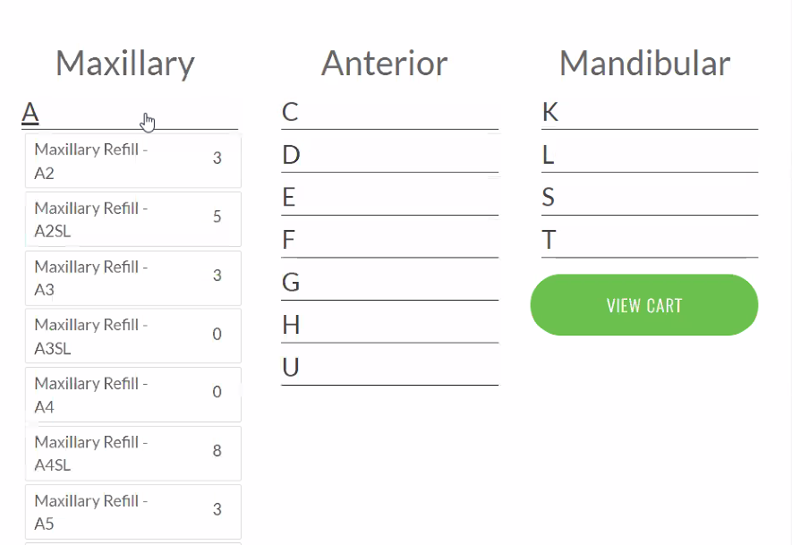
Also, when it’s adding they want a progress bar to show progress.
Use cart, addLines, addMultiple. (Also replace the cart when they come back to the page)

They also want a pop up window like this native one:
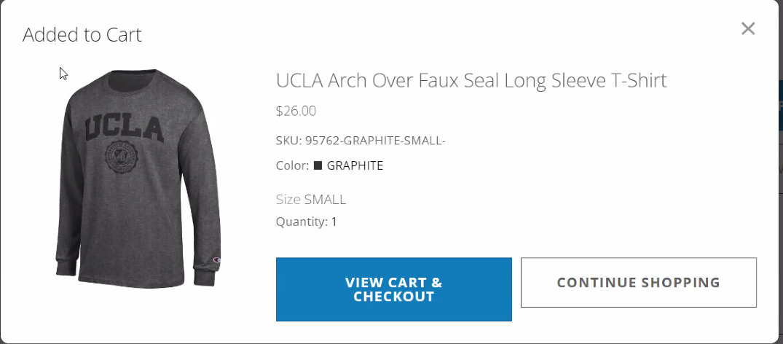
Use modal.

SKU 1: 5 (Every of the items selected)
SKU 2: 3
SKU 3: 1

